**MODUL 4. KOMBINASI GERBANG LOGIKA**

Nama : Auzan Danar Kusuma  
NIM : L200180005  
Kelas : A

**Percobaan 1. Substitusi Pengganti Gerbang Logika**

1. Fungsi boolean : L1 =  = 
2. Tabel kebenaran

|  |  |  |
| --- | --- | --- |
| **SW 1** | **L2** | **L1** |
| 0 | 0 | 1 |
| 1 | 1 | 0 |

|  |  |
| --- | --- |
|  |  |
| 0 | 1 |
|  |  |
| 1 | 0 |

1. Diagram waktu

L2  
  
  
  
  
  
  
  
  
  
L1

1. Kesimpulan :

Gerbang NOR pada percobaan 1 membentuk logika dari gerbang **NOT .**

**Percobaan 2. Substitusi Pengganti Gerbang Logika**

1. Fungsi boolean : L3 =  = L1 + L2
2. Tabel kebenaran

|  |  |  |  |  |
| --- | --- | --- | --- | --- |
| **SW 1** | **SW 2** | **L1** | **L2** | **L3** |
| 0 | 0 | 0 | 0 | 0 |
| 1 | 0 | 1 | 0 | 1 |
| 0 | 1 | 0 | 1 | 1 |
| 1 | 1 | 1 | 1 | 1 |

1. Diagram waktu

|  |  |  |  |
| --- | --- | --- | --- |
|  |  |  |  |
| 0 | 1 | 0 | 1 |
|  |  |  |  |
| 0 | 0 | 1 | 1 |
|  |  |  |  |
| 0 | 1 | 1 | 1 |

L1

L2

L3

1. Kesimpulan :

Gerbang NOR pada percobaan 2 membentuk logika dari gerbang OR.

**Percobaan 3. Substitusi pengganti gerbang logika**

1. Fungsi boolean : L3 =  = L1L2 atau L1.L2
2. Tabel kebenaran

|  |  |  |  |  |
| --- | --- | --- | --- | --- |
| **SW 1** | **SW 2** | **L1** | **L2** | **L3** |
| 0 | 0 | 0 | 0 | 0 |
| 1 | 0 | 1 | 0 | 0 |
| 0 | 1 | 0 | 1 | 0 |
| 1 | 1 | 1 | 1 | 1 |

1. Diagram waktu

|  |  |  |  |
| --- | --- | --- | --- |
|  |  |  |  |
| 0 | 1 | 0 | 1 |
|  |  |  |  |
| 0 | 0 | 1 | 1 |
|  |  |  |  |
| 0 | 0 | 0 | 1 |

L1

L2

L3

1. Kesimpulan

Gerbang NOR pada percobaan 3 membentuk logika dari gerbang AND.

**Percobaan 4. Substitusi Pengganti Gerbang Logika**

* 1. Fungsi boolean : L3 =  + L1 L2 = 
  2. Tabel kebenaran

|  |  |  |  |  |
| --- | --- | --- | --- | --- |
| **SW 1** | **SW 2** | **L1** | **L2** | **L3** |
| 0 | 0 | 0 | 0 | 1 |
| 1 | 0 | 1 | 0 | 0 |
| 0 | 1 | 0 | 1 | 0 |
| 1 | 1 | 1 | 1 | 1 |

* 1. Diagram waktu

|  |  |  |  |
| --- | --- | --- | --- |
|  |  |  |  |
| 0 | 1 | 0 | 1 |
|  |  |  |  |
| 0 | 0 | 1 | 1 |
|  |  |  |  |
| 1 | 0 | 0 | 1 |

L1

L2

L3

4. Kesimpulan

Gerbang NOR pada percobaan 4 membentuk logika dari gerbang XNOR.

**Percobaan 5. Substitusi Pengganti Gerbang Logika**

1. Rangkaian

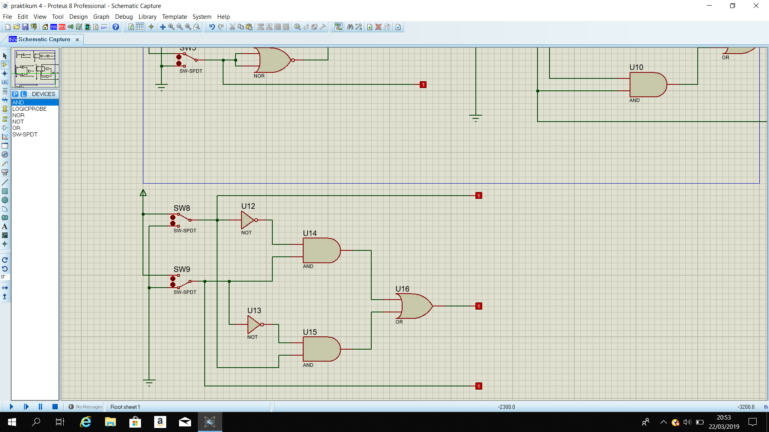

1. Fungsi boolean : L3 = ̅̅ ̅ L2 + L1  = L1 L2
2. Tabel kebenaran

|  |  |  |  |  |
| --- | --- | --- | --- | --- |
| **SW 1** | **SW 2** | **L1** | **L2** | **L3** |
| 0 | 0 | 0 | 0 | 0 |
| 1 | 0 | 1 | 0 | 1 |
| 0 | 1 | 0 | 1 | 1 |
| 1 | 1 | 1 | 1 | 0 |

1. Diagram waktu

|  |  |  |  |
| --- | --- | --- | --- |
|  |  |  |  |
| 0 | 1 | 0 | 1 |
|  |  |  |  |
| 0 | 0 | 1 | 1 |
|  |  |  |  |
| 0 | 1 | 1 | 0 |

L1

L2

L3

1. Kesimpulan

Gerbang NOR pada percobaan 5 membentuk logika dari gerbang **XOR.**